**Head Start Project Manual**

**Proposal:**

The Head Start program was put together for the Students and volunteers over at Dominican University. The purpose of the head start program is to provide these students and volunteers with the opportunity to further their cultural understanding, promote nutrition and health, and offer flexibility for the variety of interests and skills that students have on campus. The mission of Head Start, per their scholarly news source, is as follows:

“Head Start is a federally funded government program designed to provide nutrition services and other health services to people in low-income neighborhoods where health disparities arise.”

As well as

“The mission of Head Start is to promote equity through health and nutrition services, which is where Dominican University comes in.”

Our goal for this project is to take the current state and move it to a place where the program will be able to use it as a virtual timesheet. They currently track the records of their students as well as volunteers on paper, but we would like to move that to an application. As far as features go, we never had a chance to meet with the people from the Head Start program early on in the semester so we were unable to get any extra information towards the application. Our main goals as a team are to familiarize ourselves with the program files as well as the application as a whole, identify all required materials as well as architectural dependencies for the application, attempt to get the application to run and operate successfully, and then make any additions that we feel are necessary or beneficial to the project. One thing that we had realized as a team is that none of us are well versed when it comes to program / application development. We all have different strengths that play into different fields within Computer Science so this project will be tricky for us to manage, but we want to put our best foot forward and give it our all. What we are going to do to accomplish these goals is simple, we have to begin by identifying all necessary components of this application and study them. We want to familiarize ourselves with the project so that we have a better understanding moving forward. We then want to figure out and determine our next steps for running the application and bringing it to life. After that, we have to plan on what features we’ like to add to the application and how we will execute that. Our plan is to meet weekly so that we can go over our findings and push our involvement into the application further.

**Requirements:**

This project is the largest out of anything my group has ever done, and with that it brings along a lot of requirements. I’ll start this off by providing a list of these requirements along with their descriptions to allow for a better understanding of what they do and why we require them.

DropBox - We used dropbox as a way to share project files in between one another so that we can consolidate application / project files.

*Installation: By heading to the Website for DropBox you are able to create a free account and start sharing with friends or team members instantly.*

Visual Studio Code - Visual Studio Code is the code editor and platform we will be using to build and compile our project source files.

*Installation: You can visit* [*https://code.visualstudio.com/download*](https://code.visualstudio.com/download) *to download the latest version of visual studio for your device.*

Node.Js *-* Node.Js was used within our application because it provides the best functionality overall. Since Node.js works on a non-blocking I/O model, it allows for impressive speed when dealing with server side tasks.

*Installation: You can download Node.Js from the provided link:* [*https://nodejs.org/en/download/*](https://nodejs.org/en/download/)

React - React is the primary library we use for our user interface. The benefit you get when using React is that it's built on SPA (Single Page Application) architecture. This means that making changes to or updating content on a page does not require a total refresh. Ex) Posting a comment on a FaceBook photo.

*Installation: If you’re using google chrome, yo can download a version of Reacts Developer tools here* [*https://chrome.google.com/webstore/detail/react-developer-tools/fmkadmapgofadopljbjfkapdkoienihi?hl=en*](https://chrome.google.com/webstore/detail/react-developer-tools/fmkadmapgofadopljbjfkapdkoienihi?hl=en)

Redux - We use Redux in conjunction with React to manage our application.

*Installation: If you’re using google chrome, you can download a version of the Redux Developer tools here* [*https://chrome.google.com/webstore/detail/redux-devtools/lmhkpmbekcpmknklioeibfkpmmfibljd?hl=en*](https://chrome.google.com/webstore/detail/redux-devtools/lmhkpmbekcpmknklioeibfkpmmfibljd?hl=en)

Yarn - We use yarn as a package manager which handles any necessary package updates and changes.

*Installation: A classic download for a windows version of Yarn can be found by following the link:* [*https://classic.yarnpkg.com/en/docs/install/#windows-stable*](https://classic.yarnpkg.com/en/docs/install/#windows-stable)

MongoDB Compass - We use MongoDB Compass to have access to all stored data that goes into our application. This allows for seamless integration as well as ease of use when viewing and editing data.

*Installation: A free version of the MongoDB compass can be found by following the provided link* [*https://www.mongodb.com/try/download/compass*](https://www.mongodb.com/try/download/compass)

MongoDB Community - MongoDB Community is the server that we run our application on.

*Installation: The download for MongoDB’s community server can be found here at this link address* [*https://www.mongodb.com/try/download/community*](https://www.mongodb.com/try/download/community)

**Database:**

The database that we were using during the creation of our application is MongoDB. We chose MongoDB because we thought it was the most intuitive as well as easiest for us since it was previously incorporated into the project files. We accessed our data through an application called MongoDB Compass. Our primary forms of data within our application are the user credentials for each individual account upon its creation, and then the data that is to be used for adding timesheets into the program. First, I’ll add a more detailed photo of our Data model, then I will attach the Entity- Relational diagram I had created, and finally snips of our database.

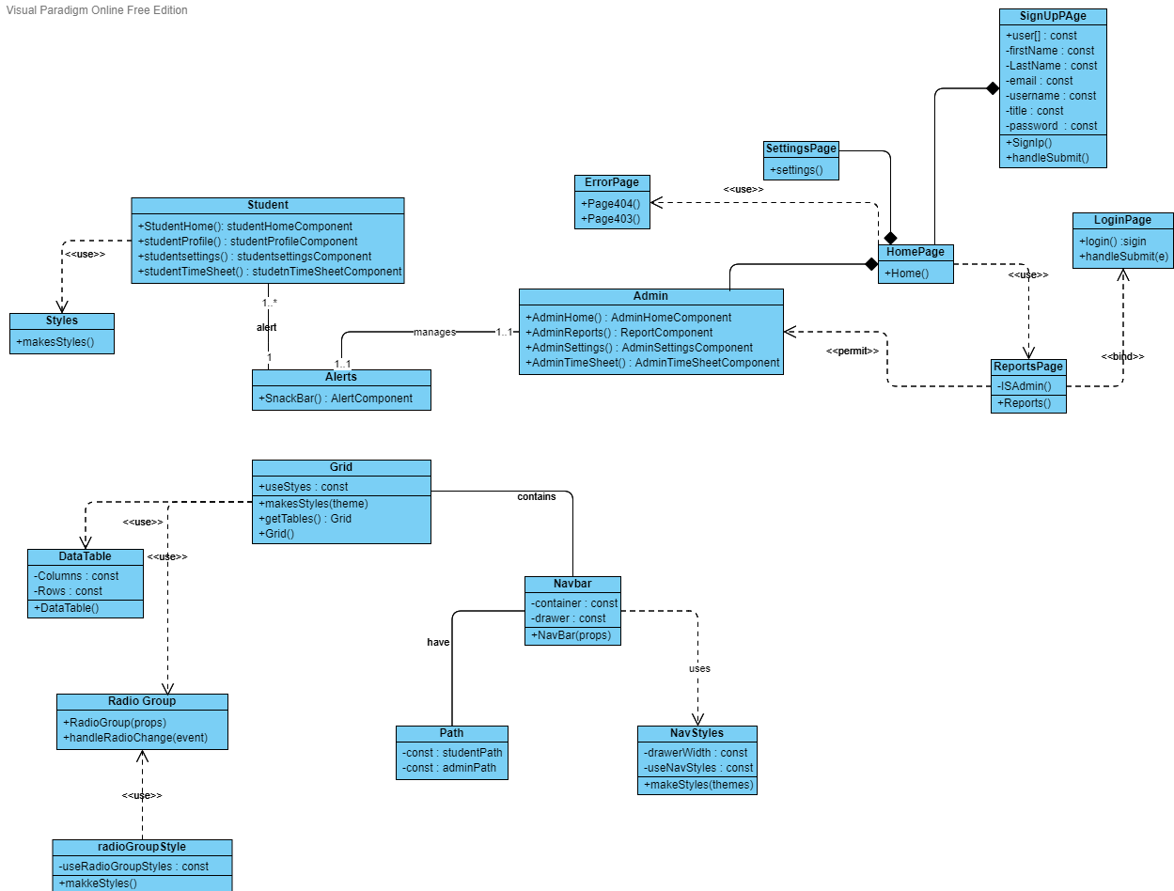

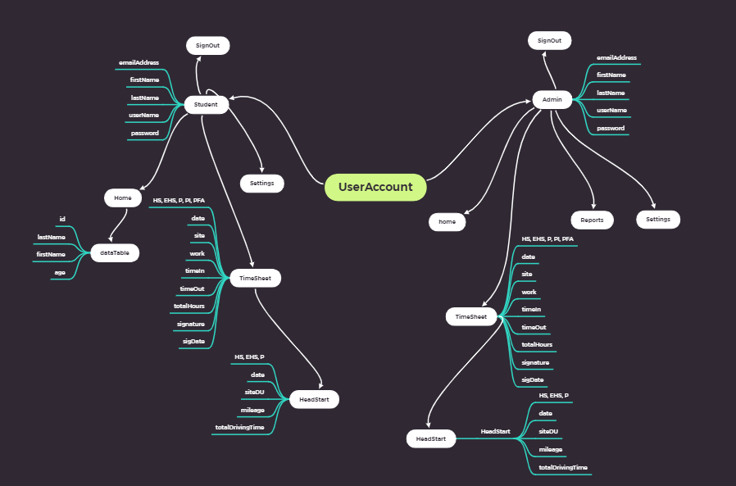

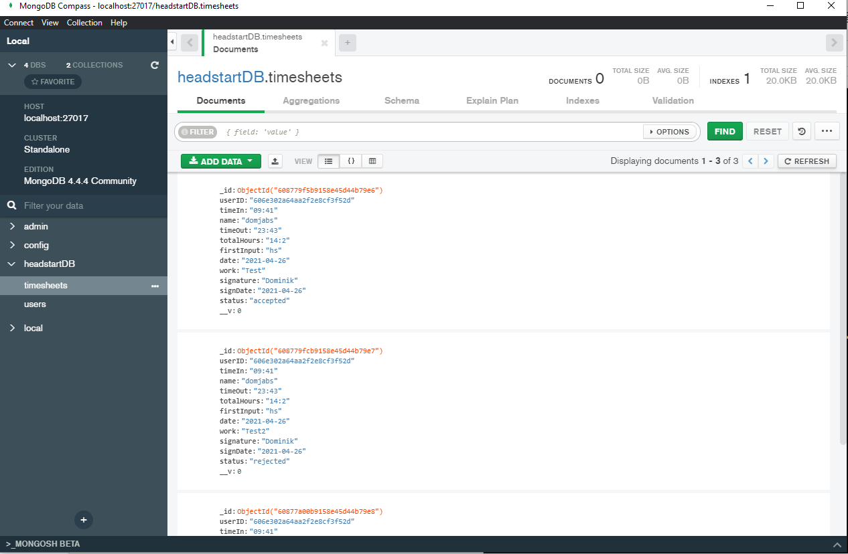

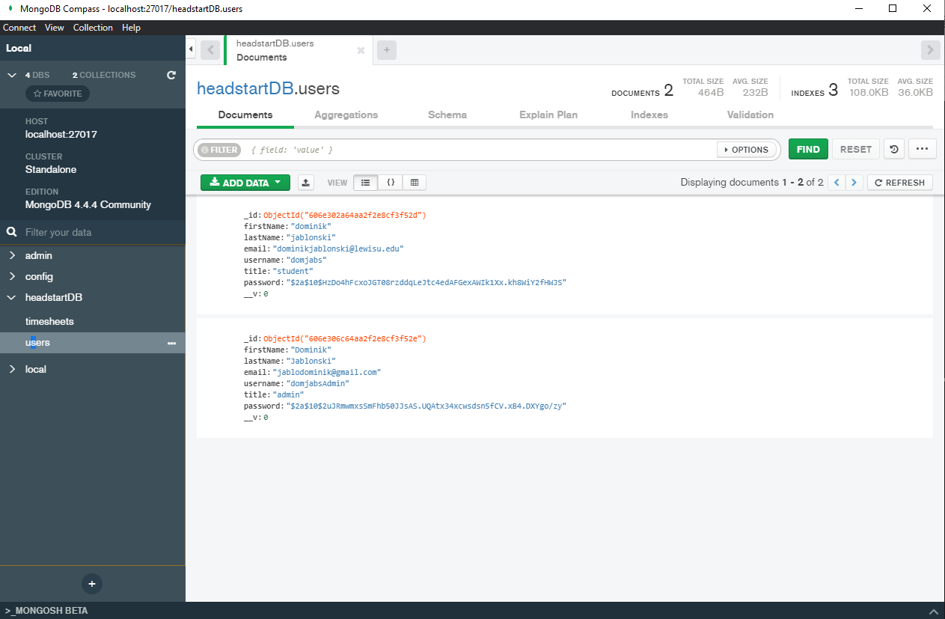

**Application Workflow:**

We wanted the usability of the application to remain simple so that users can navigate through and get all necessary actions done as quickly as possible. We like how simple the original design was so we decided it was a good idea to preserve that. We start by introducing the user with a very simplified login / account creation screen on the first entry within the website. Once a user has accessed their account, they are then led to their home page, which offers a very simple and straightforward navigation bar on the left-hand side of the screen for quick and efficient usability. The workflow of our application will be shown in the following photos, they are in order.

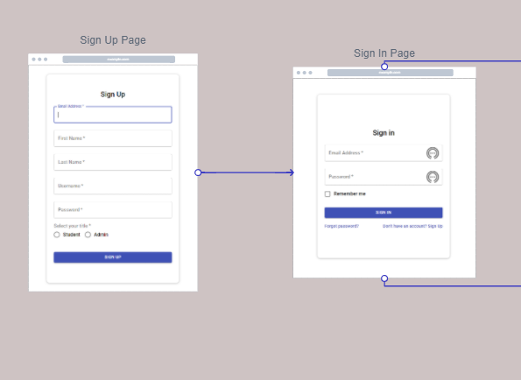

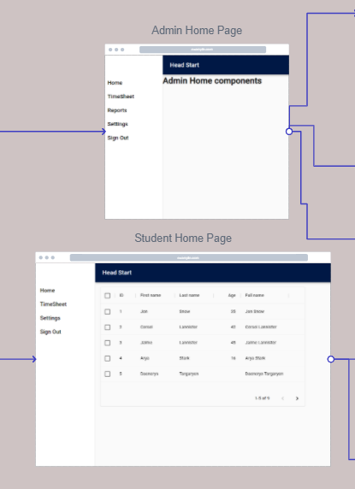

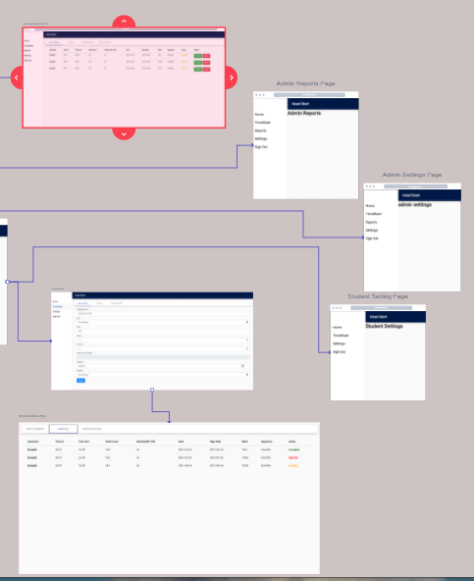

**Features Table:**

|  |  |  |  |
| --- | --- | --- | --- |
| **Feature** | **Software** | **Future: Yes** | **Future: No** |
| **TimeSheet** | **React** |  | **X** |
| **AcceptTimeSheet** | **React** |  | **X** |
| **RejectTimeSheet** | **React** |  | **X** |
| **Social Media** |  | **X** |  |

**Project Planning:**

Our team primarily used Zoom, SMS text messaging, and dropbox when handling all planning towards our application this year. From the beginning of this semester, we knew that this project was not only going to be difficult to complete from a programming standpoint, but also from a collaborative standpoint. COVID had made juggling coursework extremely difficult, making an already hard project, even harder. As we had met with our team for the first couple of sessions, we had agreed that the best way for us to communicate properly as well as share any information regarding the project was through the channels that I had mentioned earlier.

Each of these had their benefits for us. Being able to communicate over text allowed us to be in contact with one another in regards to the project whether or not we were engaged in other lectures, or if we were at work. To us, using GitHub was actually detrimental toward our progression as we would not be able to see what's going on with the project if we were busy. Using these forms of communication we had determined at the start of the Semester who would be handling the research for which part of our application. I (Domink) was in charge of researching the back-end of our application so that we can learn how to get it to run. Nathan was in charge of identifying and familiarizing himself with the front-end so that we know how the application is connected as a whole. Lubna was to familiarize herself with the Head Start program as a whole so that we can understand what their goals are as an organization, as well as aid in any research and testing when getting the application to run. As our understanding was growing, we had begun developing the Node Graph. I had started putting together the TimeSheet node within our graph, as well as working on the Data model / Class diagram. Lubna was to curate the reports portion of the Node Graph, and Nathan was in charge of putting together the SignUp page as well as writing up the first draft of our Project Manual. Once we got passed this point in the project, we had to keep trying to get the program to run. After weeks of failed attempts and growing frustration, I had taken initiative in taking application development courses online to help me figure out how to run the application. After this, I was able to finally get the program running by learning which terminal commands I needed to use to get both the front-end and back-end of the code running, then dinging the URL for the application within the code so that I can actually connect to the website. Once I had put this all together, my next goal was to add the ability to input user TimeSheets into the application so they can begin moving from paper to digital. The next process for our team was for me (Dominik) to try and implement the time sheet feature into our application so that we can show the potential an application like this has. Lubna and Nathan were to put together a few slides going over database and server options for the head start program so they can eventually turn this into a fully functioning piece of their organization. We knew that we weren’t able to fully finish this project as a whole, especially due to the fact that our overall expertise in this type of work was very limited. With this in mind, we were very proud of the work we were able to accomplish and hope another group can carry on this project and make it even greater. Our final step is to add our new features to our previous presentation and upload it as our last contribution.

**Test Planning:**

Our testing was primarily focused around the timesheet that I had implemented. Our focus was to ensure that all of the input boxes for the timesheet ensured that the correct values were being inserted and would throw an error if not. We also wanted to make sure the status feature worked as well. What we did to do this was test the timesheet a variety of times with inputting many different characters or strings within the input boxes to ensure that it would not accept anything other than what it expects to. It also does not let you submit a timesheet unless your time put in is going forward, if it goes backward the submission will not go through.We did not have much of a feature list so this was basically all the testing that we had to do to ensure our application was working as intended.

**Conclusion:**

In conclusion, we did not get to accomplish all of our goals, but what we did accomplish, we are extremely proud of. Going into this project with little experience, and very average knowledge with the task at hand, our hopes were brought down very low. We did not let that stop us. We gave this project our all, we spent hours and hours on end trying to learn the ins and outs, the features, the architecture, and the code so that we could give it an honest try. We are extremely satisfied with ourselves because we had learned way more than any of us would have expected. We valued our time working within our group and hope that everyone had the chance to learn something new within their respective projects. From the initial learning phase of our project, to the data models, the node graphs, the hours of testing and learning, to the addition of the timesheet, we had a blast being able to learn. We had plenty of goals and dreams for our application, but many of them had unfortunately fallen short. One idea that we had for the future of the head start program was to create a social media type of an environment for those who are either working with the program itself, or those who are being helped by the program. Creating a positive ecosystem for the people involved by this can be extremely beneficial to character development as well as long term positive effects of these individuals' lives. It can create life long bonds and friendships all while being easily accessible within one centralized hub. Employees and volunteers of Head Start would be apple to do fun games over the web, connect with individuals through personal messaging, and even set up in person events and easily let everyone know by posting it to a central announcement board for all to see. We see a very bright future for the program, the possibilities are endless. We thank Dr. Lewis as well as Head Start for the opportunity to work on this project, and we wish all parties involved good luck in their future!